Ticket-to-Machine, Not Ticket-to-Human: Why Changing State Isn’t Compliance Evidence (Standalone Edition)
  - Azure, AWS, and VMware’s own tools remediate; ServiceNow — with SailPoint ISC Governance feeding it for access governance — supplies the owner, the clock, and the evidence NIST, CISA, and FedRAMP actually require
Michael Stratton
2026-08-28
Table of contents
Ticket-to-Machine, Not Ticket-to-Human: Why Changing State Isn’t Compliance Evidence (Standalone Edition) 1
1. Executive Summary 1
2. The Question, Precisely 1
3. One Coordination Pattern, Four Platforms 1
4. Who Actuates: Ticket-to-Machine, Not Ticket-to-Human 1
5. Closure Necessity — the Same Argument, Platform by Platform 1
6. The Rollup — Every Platform, Same Verdict 1
7. The Front Door: What ServiceNow Actually Supplies 1
8. The Adjacent Domain: Access Governance and SailPoint ISC Governance 1
9. The Certificates Exception — Why PKI Doesn’t Take the Same Path 1
10. What “Just Use the Console” Actually Costs 1
11. External Validation and Build-vs-Buy (2026-07-28) 1
12. Honest Limits 1
13. The Ask — Spoke Coverage Under the Agency Contract 1
14. Vendor Currency 1
References 1

Ticket-to-Machine, Not Ticket-to-Human: Why Changing State Isn’t Compliance Evidence (Standalone Edition)

1. Executive Summary
The question this paper answers: if the agency already has Azure Portal, the AWS Console, vCenter/CPS, and a ServiceNow + SailPoint stack, why not just let the native tools handle compliance directly?
The short answer is that native cloud and virtualization consoles are excellent at one job — changing state — and structurally incapable of a second, different job: producing the evidence an assessor can trace. Azure Policy, AWS Config, and VMware’s vSphere Configuration Profiles all genuinely remediate. None of them, on their own, can answer the four questions a FedRAMP assessor or an authorizing official actually asks about a finding: who owns it, by when, under whose approval, and with what evidence. That is not a criticism of the native tools — it is a recognition that “the console shows green” and “the authorization package has a traceable, owned, evidenced record” are different claims, and only one of them is what NIST SP 800-53, CISA directives, and FedRAMP require.
A ticket alone does not close that gap either — this is the point this paper exists to make. The default shape of change management in most estates today is ticket → a human opens the console (or runs a script) because the ticket told them to → replies “done.” Adding a ServiceNow ticket in front of that does not change who is at the keyboard. §4 states this plainly: the ticket has to authorize a machine to execute, not a person to click through the same console the ticket was raised about — that distinction, not merely “have a ticketing system,” is what this paper is actually recommending.
 Key Finding
Across every platform examined in this paper — Microsoft 365, Azure, AWS, and VMware — the control-closure analysis behind it marks CM-6 (Configuration Settings) as Tool-attestable: No, without exception, regardless of vendor; the three IaaS/hybrid platforms (Azure, AWS, VMware) additionally carry RA-5 (Vulnerability Monitoring and Scanning) and SI-2 (Flaw Remediation) with the same verdict — M365 is Microsoft-managed SaaS and never reaches a control-closure table for those two at all. This is not an oversight or a gap waiting to be closed by the next product release — it is the structural finding of this paper: no native console, by itself, produces the ownership/clock/approval/evidence record FedRAMP evidence requires. That record comes from a coordination layer — ServiceNow, with SailPoint ISC Governance feeding it detection findings for the adjacent access-governance domain — sitting in front of the native tools, not replacing them.

What this edition asks of the ServiceNow team
This edition is written for the agency’s internal ServiceNow team. The argument below is the why; the request is in §13. Everything §§3–8 describe depends on ServiceNow being able to reach four native surfaces — Entra ID/Azure, AWS, and VMware — under a service identity, with ServiceNow acting as the approval front end both for SAM (Systems Access Manager) access requests and for configuration, vulnerability, and patch findings. On the ServiceNow side that reach is an IntegrationHub spoke, and spokes are a licensed entitlement rather than a platform feature. §13 asks the team to confirm which of those spokes the agency’s current contract covers, and to name the gaps.

2. The Question, Precisely
“Does the native cloud portal already do this?” is really three separate questions that get collapsed into one:
- Can the native tool detect drift and change state? Yes — this paper does not dispute that Azure Policy, AWS Config, and vSphere Configuration Profiles genuinely remediate.
- Can the native tool’s own dashboard show current compliance posture? Yes, for its own boundary — Defender for Cloud, Security Hub, and VCF Operations all show a live posture picture.
- Can the native tool’s dashboard, by itself, serve as the evidence artifact an assessor relies on for an ATO decision? No. This is the question this paper is actually about, and the answer is the same across every platform surveyed.
The reason the answer is uniformly “no” is not a per-vendor product gap; it is structural. A console shows current state. An evidence record has to show who owns the finding, the clock they are working against, the approval trail for any exception, and a re-test that proves closure — a governance wrapper, not a dashboard, and none of the three platforms’ native consoles are built to be a system of record for ownership and approval across an organization’s workflow.

3. One Coordination Pattern, Four Platforms
This pattern is documented once and applies identically across Microsoft 365, Azure, AWS, and VMware — the same five-step loop over each platform’s native control engines:
Test → Detect drift → Raise a typed task against the reconciled CI → Actuate on the native surface → Close with evidence.
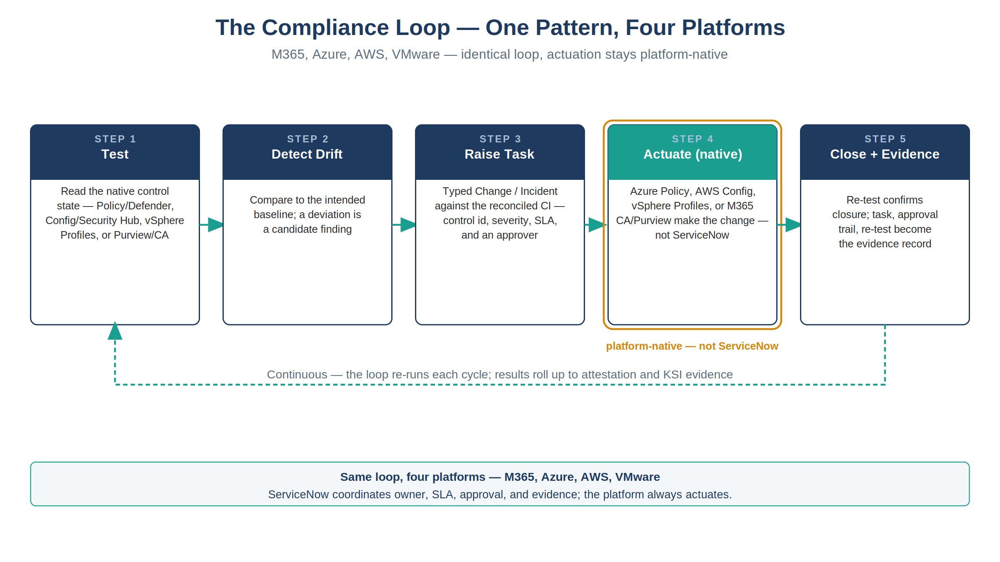
Figure 1: The compliance loop, identical across M365, Azure, AWS, and VMware — actuation always stays platform-native
Actuation always stays platform-native. ServiceNow’s role is never to write the configuration, apply the patch, or fix the firewall rule — it is to make sure every drift becomes an owned, clocked, approved, evidenced piece of work, whichever native engine ultimately does the actuating.
Platform | Native engines (actuate) | Controls covered | What the console alone cannot show
Microsoft 365 | Conditional Access, Purview | CM-6 | Owner, SLA, approval trail, exception review
Azure | Azure Policy, Defender for Cloud, MDVM, Update Manager (+ Arc for hybrid) | CM-6, RA-5, SI-2 | Same
AWS | AWS Config, Security Hub CSPM (+ GuardDuty, Inspector), Systems Manager Patch Manager | CM-2/CM-6, CM-6/RA-5, SI-2 | Same
VMware | vSphere Configuration Profiles, VCF Operations + NSX Distributed Firewall, vSphere Lifecycle Manager (vLCM) | CM-2/CM-6, CM-6/RA-5, SI-2 | Same
M365’s row is shorter than the other three for a structural reason, not an omission: it is Microsoft-managed SaaS, so there is no customer-facing vulnerability-scanning or patch-management surface the way the IaaS/hybrid platforms have (Defender for Cloud + MDVM + Update Manager, Security Hub + GuardDuty + Inspector + Patch Manager, VCF Operations + NSX + vLCM) — Microsoft owns that layer, so RA-5 and SI-2 never reach the tenant’s own control-closure table in the first place. The M365 control-closure analysis behind this paper covers exactly three controls — AC-2, CA-7, CM-6 — confirming this, not asserting it.
VMware is worth calling out specifically, because it breaks the pattern people expect: unlike M365, Azure, and AWS — boundaries reached over a cloud provider’s API — VMware is the agency’s own on-premises or agency-operated virtualization estate, racked and patched directly. The same evidence gap exists anyway. Owning the hardware does not produce an owner, a clock, or an approval trail any more than renting a CSP subscription does; vCenter’s own console shows green on exactly the same terms Azure’s and AWS’s consoles do.

4. Who Actuates: Ticket-to-Machine, Not Ticket-to-Human
The gap described above has an obvious-looking fix that is itself a trap: raise a ServiceNow ticket for every finding and call the gap closed. It isn’t, if what happens next is still a human logging into the Azure Portal, the AWS Console, or vCenter — or running a script by hand — because the ticket told them to. That is the default shape of change management in most estates today: ticket → a human opens a console or runs a script → replies “done.” This paper’s coordination-layer argument does not automatically fix that pattern; it can look fixed while execution stays exactly where it always was, at a keyboard. Closing that gap — not merely adding a ticketing system in front of the same manual process — is this paper’s central recommendation.
 Recommendation
The ticket should authorize a machine, not a person, wherever a machine can reach the surface. A human approves the change in ServiceNow; Azure Policy, AWS Config, vSphere Configuration Profiles, an orchestration runbook, or the ServiceNow MID Server itself executes it under a service identity. The human’s role stops at approval — the platform, not the person, is the actuator. This is the same “actuation always stays platform-native” claim from §3, stated as a rule about who touches the keyboard, not only about which console shows the change.

Why a machine actuator, specifically. Running a change through an orchestrator produces, automatically, everything a 3PAO or authorizing official actually checks for: the change traces to a prior approval, the artifact that ran is version-controlled and access-restricted, the execution is logged and attributable to the task rather than to a person’s memory, and the result is a re-testable, reproducible record rather than a “trust me” reply. A human at a console produces none of that unless every one of those properties is separately, manually reconstructed — a real cost, paid every time, that a machine actuator pays once, in the orchestrator’s own design.
This is a strong recommendation, not a citable prohibition — and this paper says so plainly rather than overstating it. No NIST SP 800-53 control bars a human from executing an approved change, and FedRAMP’s own KSI-CMT-RMV (redeploy version-controlled resources rather than modify directly) is itself qualified “wherever reasonable” — an engineering preference with a documented-exception path, not a ban. The supporting control set is CM-3/CM-3(2)/CM-5/CM-7/CM-11/CM-14, AU-2/AU-12/AC-6(9), and KSI-CMT-RMV/VTD/RVP, together with the specific FedRAMP Rev 5 Moderate baseline enhancements that actually mandate automation — CM-3(2), CM-5(1), CM-6(1), and SI-2(2) — each checked directly against FedRAMP’s own published baseline profile rather than asserted.
The anti-pattern gets worse, not better, when detection is automated. SailPoint flags an over-privileged entitlement, or a posture engine flags a drifted setting — and instead of opening the ServiceNow task this paper’s whole architecture depends on, the finding goes out as an email with a script attached, and a human runs it directly against the console. That path never touches ServiceNow at all: no owner, no clock, no approval trail, no re-test evidence — the exact console-only failure mode §10 describes, just reached by a different door. A notification email, if one exists, announces that work is needed; it is never the approval and never the record.
Where no machine actuator exists yet, the fallback is a declared exception, not a silent one. VMware/vCenter is the recurring case: no confirmed orchestrator today runs a signed script against vCenter under a service identity. The compensating control is a CyberArk Privileged Session Manager (PSM) session — approved first in ServiceNow, then time-boxed, proxied, and recorded — with the recording itself as the evidence artifact. That closure is booked honestly as a documented-process closure, not represented as automated validation it cannot provide.

5. Closure Necessity — the Same Argument, Platform by Platform
The same finding holds on each platform, in the same words, changing only the vendor name. Setting all three side by side makes the structural (not vendor-specific) nature of the claim concrete:
 Azure
Azure Policy remediates, Defender recommends, Update Manager patches — the native stack is genuinely sufficient to change state. What it does not supply is the governance wrapper: who owns this finding, by when, under whose approval, with what evidence. Strip the coordination layer and Azure’s own consoles show green while the authorization package has no owned-and-evidenced record an assessor can trace.

 AWS
AWS Config remediates, Security Hub CSPM surfaces, Patch Manager patches — the native stack is genuinely sufficient to change state. What it does not supply is the governance wrapper: who owns this finding, by when, under whose approval, with what evidence. Strip the coordination layer and AWS’s own consoles show green while the authorization package has no owned-and-evidenced record an assessor can trace.

 VMware
vSphere Configuration Profiles remediates, VCF Operations and NSX DFW surface, vLCM patches — the native stack is genuinely sufficient to change state, on the agency’s own hardware exactly as it is on a hyperscaler’s. What it does not supply is the governance wrapper: who owns this finding, by when, under whose approval, with what evidence. Strip the coordination layer and vCenter’s own console shows green while the authorization package has no owned-and-evidenced record an assessor can trace.

In each case: CM-6, SI-2, and RA-5 are closed by the platform; they are operated — owned, clocked, evidenced — by the coordination layer.

6. The Rollup — Every Platform, Same Verdict
The table below consolidates the Tool-attestable? verdict for every control examined above, plus the attestation-stage controls. Every row reads No — not because the tooling is immature, but because “tool-attestable” and “evidence the platform console alone can produce” are the same test, applied consistently.
Control | Title | Platforms it recurs across | Tool-attestable?
CM-2 / CM-6 | Baseline Configuration / Configuration Settings | M365, Azure, AWS, VMware | No
RA-5 | Vulnerability Monitoring and Scanning | Azure, AWS, VMware | No
SI-2 | Flaw Remediation | Azure, AWS, VMware | No
CA-2 | Control Assessments | Attestation layer, fed by all four platforms | No
CA-5 | Plan of Action and Milestones | Attestation layer | No
CA-7 | Continuous Monitoring | Attestation layer | No

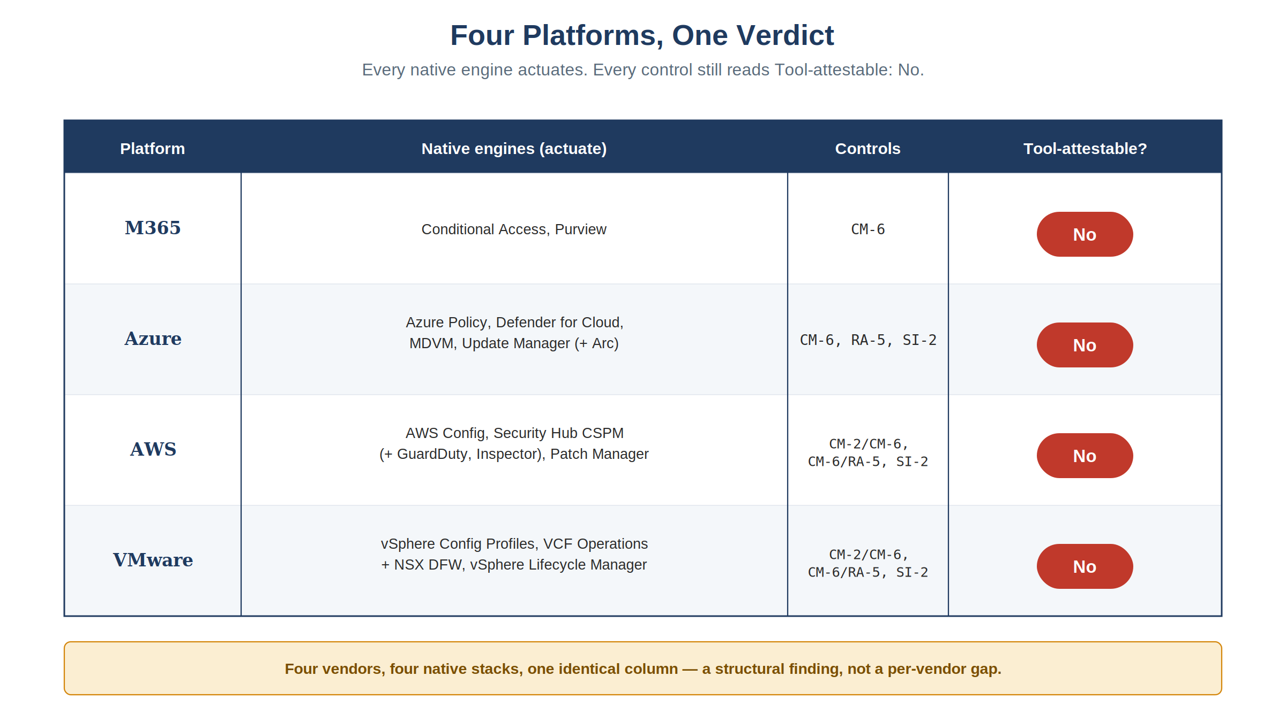
Figure 2: Four platforms, one verdict — every native engine actuates, every control still reads Tool-attestable: No
Four different vendors, four different native stacks, one identical column of verdicts. That consistency is a single structural claim applied uniformly, not four independent confirmations of it. The external validation in §11 is the independent corroboration for that claim.

7. The Front Door: What ServiceNow Actually Supplies
All four platforms reconcile into the identical ServiceNow-side pattern, deployable today as a scoped compliance application:
- ComplianceIngest reads each platform’s native control state (Graph/SCuBA/Purview for M365; Resource Graph/Defender/Update Manager for Azure; Config/Security Hub/Patch Manager for AWS; equivalent VMware APIs) through an in-boundary MID Server — read-only against the ATO boundary.
- ComplianceReconcile matches every finding to the authoritative CMDB CI before a task is raised, so nothing routes to an orphaned or unowned asset.
- ComplianceGate re-reads the native surface after actuation and stamps the re-test evidence on the task — the mechanism that makes “closed” mean “verified,” not “claimed.”
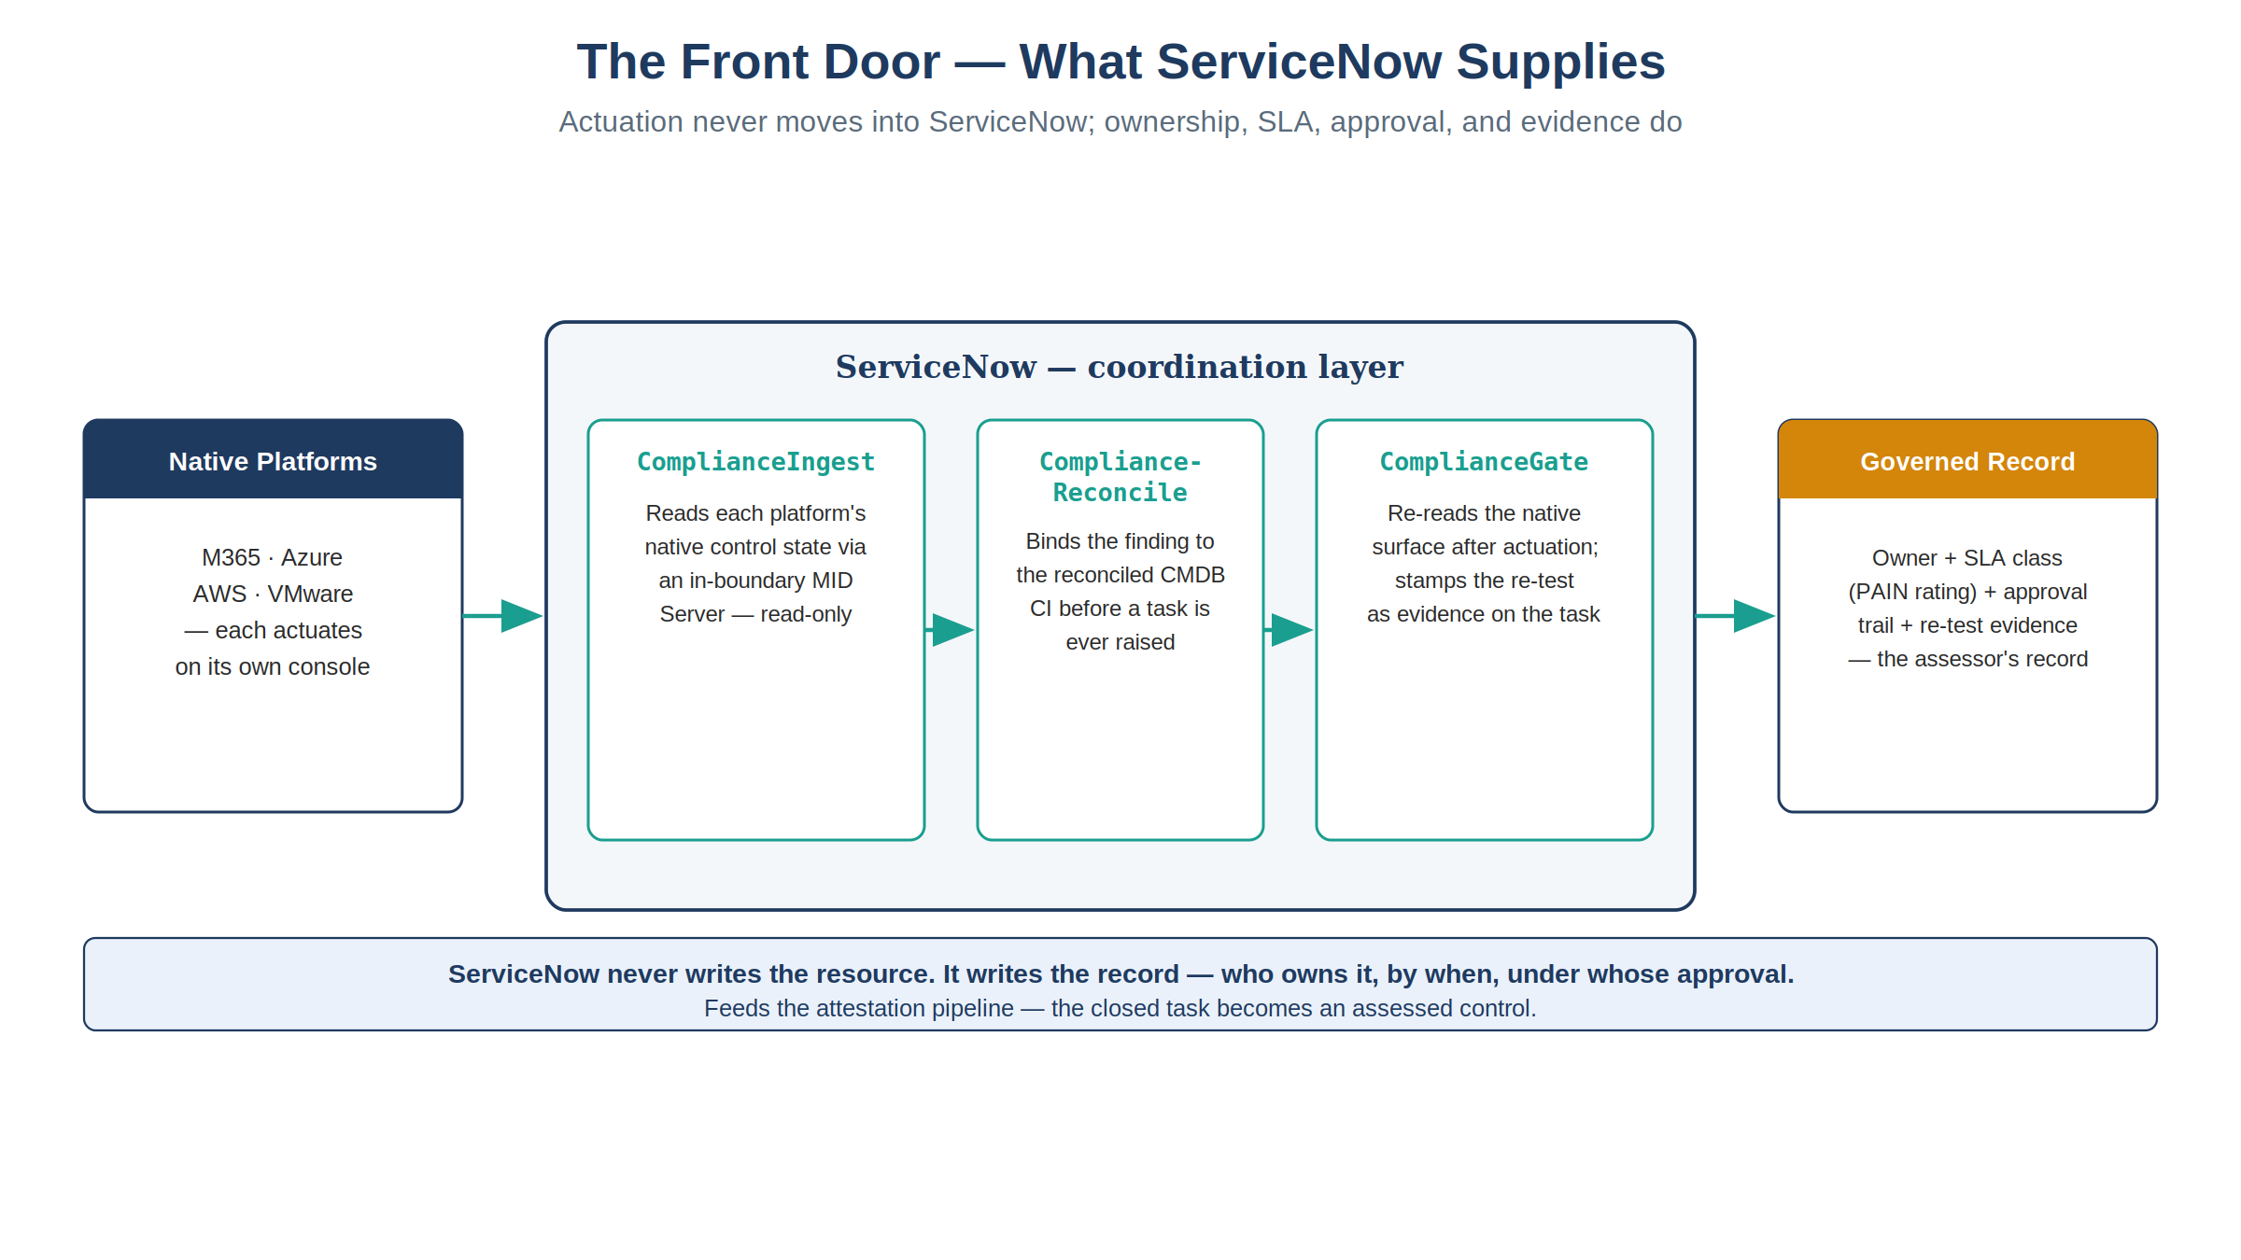
Figure 3: The ServiceNow front door — Ingest, Reconcile, and Gate sit between the native platforms and the governed record; actuation never moves into ServiceNow
Actuation never moves into ServiceNow. The native platform still remediates; ServiceNow’s entire job is the four things a console cannot do — assign an owner, attach a clock (the FedRAMP PAIN-rating SLA table, keyed to exploitability and internet-reachability, drives the SLA class), require an approval on anything that changes state or grants an exception, and capture the re-test as the evidence record.
From there, the attestation layer lifts the closed task stream into an assessed control: a scheduled IRM/GRC control test reads the actioned posture and renders pass/fail/partial with evidence attached (CA-2); any fail becomes an owned POA&M item (CA-5); the roll-up is emitted as OSCAL assessment-results and FedRAMP 20x KSI evidence (CA-7) into the authorization package.
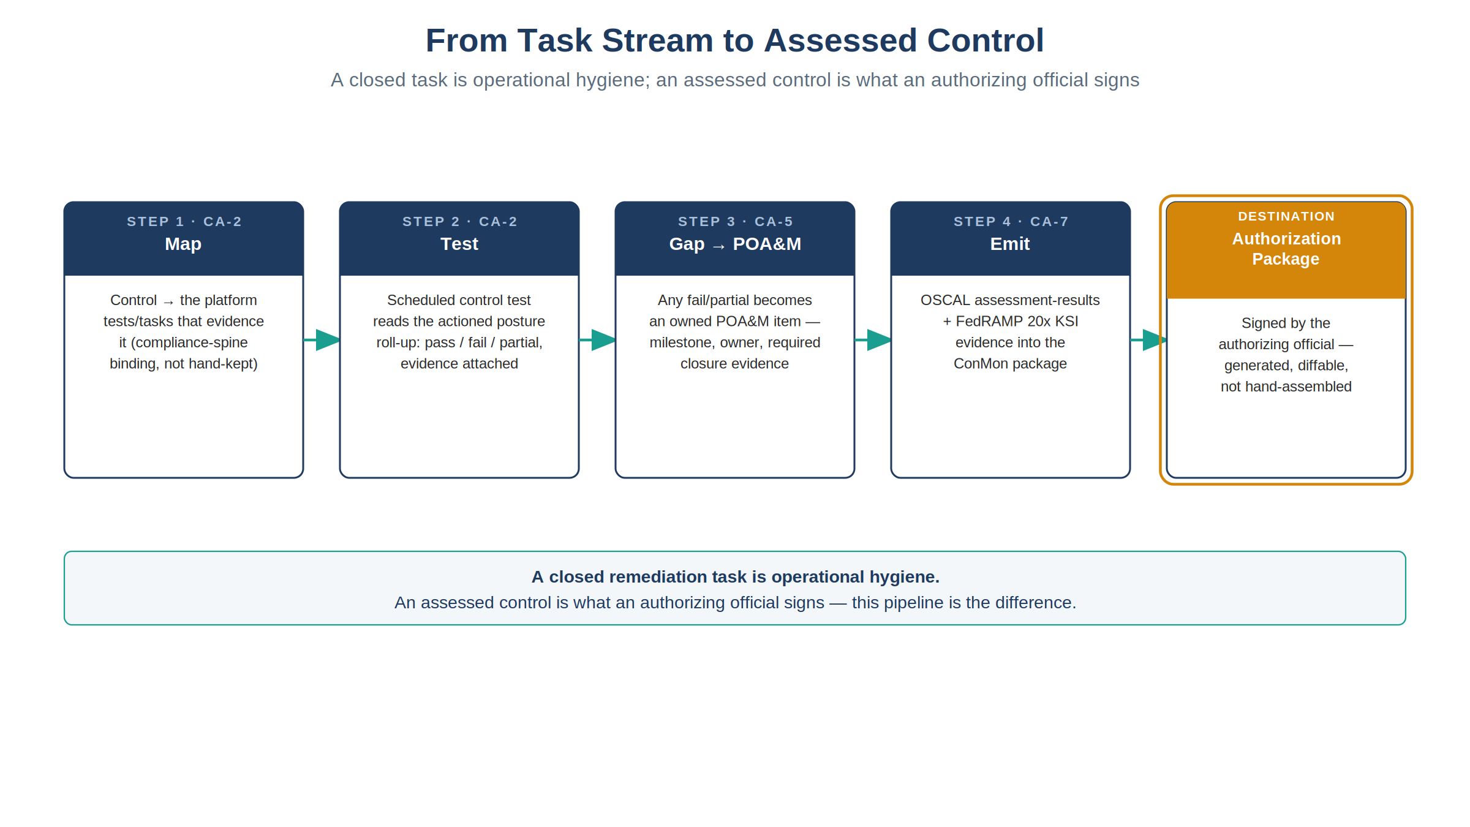
Figure 4: From task stream to assessed control — Map, Test, Gap to POA&M, Emit — feeding the authorization package
A closed remediation task is operational hygiene; an assessed control is what an authorizing official signs — the distinction the attestation layer exists to close.

8. The Adjacent Domain: Access Governance and SailPoint ISC Governance
Everything above concerns configuration, vulnerability, and patch controls (CM-6, RA-5, SI-2) — the domain the ServiceNow-fronting pattern is built and deployed for today. The same structural argument extends to a second domain, access governance (AC-2, AC-3, AC-6): a native IAM console can inspect and even remediate Azure RBAC or AWS IAM policy, but a role binding is not, by itself, a record of who requested it, who approved it, and when it was last reviewed. SailPoint ISC Governance (the CIEM add-on) supplies that detection function natively across Azure, AWS, and GCP, closing AC-2/AC-3/AC-6 through the same test → detect → raise → actuate-native → close-with-evidence loop used for configuration drift — one front door, not a second SailPoint-fronted coordination layer. VMware/vCenter identity governance remains a genuinely open gap: no evidence was found that SailPoint’s CIEM add-on reaches vCenter permissions.

9. The Certificates Exception — Why PKI Doesn’t Take the Same Path
Certificates are a large share of the actual operational work in this estate, which makes it tempting to assume they belong on the same ServiceNow-fronted path as everything else in this paper. They don’t — not for the routine lifecycle, and the reason is a deliberate doctrine call, not an oversight. IA-5(2)/SC-12/SC-17 close with protocol-enforced automation instead — ACME/SCEP/EST issuance gates, CAA records, and short-lived certificates with non-renewal replacing revocation — because the volume (thousands of issuance/renewal events a week) rules out ticket-per-event without making the ServiceNow queue meaningless. Exceptions and anomalies — a new CA, a non-standard certificate lifetime, a trust-anchor change, or a drift finding from the certificate inventory — still route through the same front door as everything else in this paper; routine issuance within policy does not.
Where tooling is needed to run that protocol-enforced path, the two candidates are CyberArk Certificate Manager — CA-agnostic discovery and orchestration, with a ServiceNow integration — and Keyfactor for Government CLAaaS, which reached FedRAMP Moderate authorization in May 2026.

10. What “Just Use the Console” Actually Costs
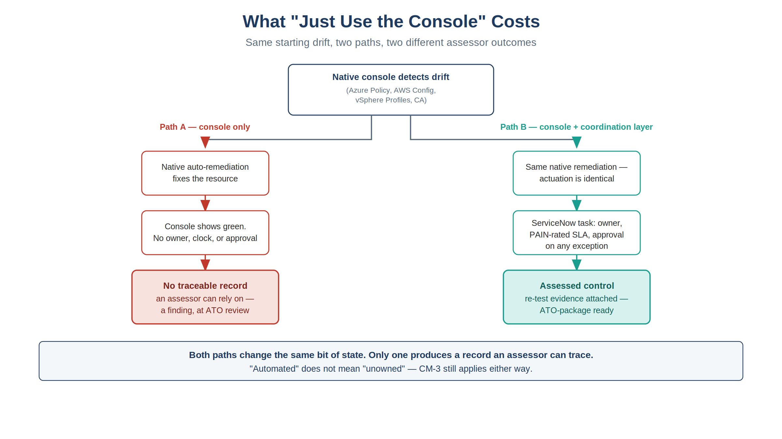
Figure 5: Same starting drift, two paths, two different assessor outcomes — only one produces a record an assessor can trace
For a customer or assessor weighing whether to skip the coordination layer and rely on native tools alone:
- The finding is real, but the record is not. Azure Policy, AWS Config, and vSphere Configuration Profiles will detect and often auto-remediate drift with no ServiceNow involvement at all. What disappears without the coordination layer is the durable, owned, approved, evidenced record of that event — the thing a 3PAO or an authorizing official is actually assessing.
- “Automated” does not mean “unowned.” Native auto-remediation (Azure’s deployIfNotExists, an AWS Config remediation action, a VMware Configuration Profiles remediation run) still requires a change record under CM-3 — automation changes who the actuator is, not whether change control applies.
- SLA-by-exposure is a specific published table, not a vague policy. FedRAMP’s Vulnerability Detection and Response ruleset (VDR-TFR-PVR) sets exact remediation timeframes by PAIN rating crossed with exploitability and reachability (4 to 192 days), plus KEV-catalog-driven due dates regardless of PAIN rating. A native console has no mechanism to enforce that clock against an owner; ServiceNow’s SLA-class task is where that enforcement actually lives.
- One coordination pattern, not one per cloud. Because the loop is identical across M365, Azure, AWS, and VMware, an organization does not need a separate governance story per platform — the evidence and the assessor-facing narrative are uniform regardless of where a given workload runs.

11. External Validation and Build-vs-Buy (2026-07-28)
This paper’s core claim — that a native console cannot be the evidence system of record — is not a position held in isolation. Independent research done the same week this paper was drafted backs it directly: the market agrees on the structural claim (Continuum GRC; Knox Systems, 2026), and it sharpens two points worth stating plainly — ServiceNow↔VMware integration is not greenfield (VMware Aria’s Management Pack, the VCF Automation ITSM plugin), and a commercial FedRAMP 20x KSI product, C1Secure SmartRAMP 20x, already competes with a custom-built scoped application for the KSI-attestation slice. It also confirms the SailPoint framing in §8 (findings route into ServiceNow, not around it) and surfaces the alternative architectures a critical reviewer will raise — Wiz’s native VMware CNAPP coverage, and the OSCAL-first Vanta/RegScale/Paramify bet that bypasses ServiceNow/SailPoint coordination altogether.
The sourcing for each of these vendor claims is listed in the References table below; §14 carries the currency caveat that applies to all of them.

12. Honest Limits
- The “machine, not human” recommendation in §4 is a derived design principle, not a citable rule — see §4 itself for the honest framing. No 800-53 control bars a human from executing an approved change, and FedRAMP’s own KSI-CMT-RMV is qualified “wherever reasonable.” The citations and the vCenter/PSM exception path are set out there; this paper states the conclusion in its main body rather than only here.
- This paper’s CM-6/RA-5/SI-2 argument is well-established across all four platforms and their control-closure verdicts; the AC-2/AC-3/AC-6 extension (§8) is likewise a documented closure — but VMware/vCenter identity governance remains genuinely open within it, per the caution in §8.
- Native-tool assessment latency (Azure Policy/Defender, AWS Config/Security Hub, VMware Configuration Profiles/VCF Operations) means “closed” in ServiceNow can lag the native platform’s own evaluation cycle by one cycle; evidence timestamps record the cycle, not the instant.
- This paper does not evaluate whether ServiceNow’s own native product modules (Configuration Compliance, Vulnerability Response/USEM, GRC: Continuous Authorization and Monitoring) already ship equivalent coordination out of the box versus requiring a custom scoped application — that is a separate build-vs-buy question, orthogonal to this paper’s claim that some coordination layer, not the native console alone, is what produces the evidence.

13. The Ask — Spoke Coverage Under the Agency Contract
The architecture in §§3–8 only works if ServiceNow can actually reach each native surface under a service identity. §4 is explicit that the ticket must authorize a machine, not a person; a ServiceNow that can raise a task but cannot reach the platform is exactly the ticket-to-human anti-pattern that section describes. On the ServiceNow side, that reach is an IntegrationHub spoke — and because spokes are a licensed entitlement, this is a contract question before it is an engineering one.
The request: for each row below, confirm whether the agency’s current ServiceNow contract entitles the integration, and where it does not, say so explicitly so the gap can be booked rather than discovered during implementation.
Platform | What this paper needs ServiceNow to reach | Integration to confirm | Status to confirm
Entra ID (AC-2/AC-3/AC-6 identity lifecycle; the SAM approval front end) | User, group, license, service-principal, password, and device actions under a delegated service account | Microsoft Entra ID Spoke (formerly the Microsoft Azure Active Directory Spoke) | Documented by ServiceNow — confirm it is entitled, and confirm the delegated account’s scope
Azure (CM-6, RA-5, SI-2) | Read Azure Policy, Defender for Cloud, and Update Manager state; raise and close typed tasks against the reconciled CI | Microsoft Azure spokes — the Virtual Machine and Virtual Network spokes are documented; which spoke, if any, covers Policy / Defender / Update Manager is the open question | Confirm both coverage and entitlement
AWS (CM-2/CM-6, RA-5, SI-2) | Read AWS Config, Security Hub, and Inspector findings and Systems Manager Patch Manager state | AWS IAM Spoke is documented; the ServiceNow AWS Integration for Security Exposure Management store app covers Inspector + Security Hub | Confirm entitlement for both, and whether Config and Patch Manager are covered
VMware (CM-2/CM-6, RA-5, SI-2) | Read vSphere Configuration Profiles / VCF Operations / vLCM state, and actuate under a service identity | No vCenter IntegrationHub spoke was found. The documented connectors are the VMware Aria Operations Management Pack for ServiceNow and the VCF Automation ITSM plugin | Confirm what the contract covers; until a machine actuator exists, the PSM exception in §4 applies
Two notes on how to read the table. The VMware row is the one this paper already flags as genuinely open (§4, §8): it is not an oversight in the table but the same gap stated in contract terms, and the honest answer may be “no spoke exists,” in which case the CyberArk PSM compensating control in §4 is the closure path rather than a workaround. And where a spoke turns out not to be entitled, the answer is not to route the work through a human at the console — that is precisely the anti-pattern §4 rejects. It is either to license the integration, or to book the gap as a declared exception with a named compensating control.
Spoke names and packaging move between ServiceNow releases, and IntegrationHub entitlement is set by subscription terms rather than by the platform; treat every product name above as a starting point for that confirmation, not as a statement of what the agency already owns. §14 applies here in full.

14. Vendor Currency
 Vendor currency caveat — read before building a Project Plan on this paper
This paper’s dated vendor claims — SmartRAMP 20x, the VMware Aria/ServiceNow connectors, SailPoint CIEM’s cloud coverage, Wiz, Vanta, CyberArk/Keyfactor — describe a market that moves in weeks, not review cycles. Every vendor claim in this paper is a dated snapshot, not a standing commitment. Confirm current roadmaps directly with ServiceNow, SailPoint, VMware/Broadcom, and each CSP before any claim here becomes the basis of an implementation Project Plan, procurement action, or acquisition decision.

References
Claim | Source
§13 — IntegrationHub spokes list (what ships, per release) | ServiceNow — https://www.servicenow.com/docs/r/integrate-applications/integration-hub/spokes-list.html
§13 — Microsoft Entra ID Spoke (formerly Microsoft Azure Active Directory Spoke) | ServiceNow — https://www.servicenow.com/docs/r/integrate-applications/integration-hub/microsoft-azure-ad-spoke.html
§13 — Microsoft Azure Virtual Machine Spoke | ServiceNow — https://www.servicenow.com/docs/r/integrate-applications/integration-hub/azure-vir-mach-spoke.html
§13 — AWS IAM Spoke | ServiceNow — https://www.servicenow.com/docs/r/yokohama/integrate-applications/integration-hub/aws-iam-spoke.html
§13 — IntegrationHub subscription terms (entitlement is contractual, not a platform feature) | ServiceNow — https://www.servicenow.com/content/dam/servicenow-assets/public/en-us/doc-type/legal/snc-addendum-integrationhub.pdf
PAIN-rating remediation timeframes (VDR-TFR-PVR) | FedRAMP — https://www.fedramp.gov/2026/reference/vulnerability-detection-and-response/
The CM-3(2)/CM-5(1)/CM-6(1)/SI-2(2) Moderate-baseline enhancements cited in §4 — checked directly against the published baseline rather than asserted | FedRAMP Rev 5 Moderate baseline profile (OSCAL) — FedRAMP_rev5_MODERATE-baseline_profile.xml
KSI-CMT-RMV/VTD/RVP text (FedRAMP Consolidated Rules for 2026, version 2026.06.24.01) | FedRAMP — https://github.com/FedRAMP/rules
Risk-based remediation prioritization (KEV catalog) | CISA — https://www.cisa.gov/known-exploited-vulnerabilities-catalog
“CSPM complements GRC — findings need owners and closure proof”; no single tool covers a FedRAMP boundary alone | Continuum GRC — https://continuumgrc.com/audit-compliance-solutions-fedramp/
Coordinated-stack requirement; ticketing/SLA ownership as a FedRAMP necessity | Knox Systems — https://knoxsystems.com/resources/continuous-compliance-fedramp
C1Secure SmartRAMP 20x — ServiceNow-native FedRAMP 20x KSI platform | PR Newswire — https://www.prnewswire.com/news-releases/c1secure-launches-smartramp-20x-a-servicenow-native-platform-built-for-the-fedramp-20x-model-302824168.html
VMware Aria Operations Management Pack for ServiceNow (native connector) | Broadcom TechDocs — https://techdocs.broadcom.com/us/en/vmware-cis/aria/aria-operations-for-integrations/9-0/management-pack-for-servicenow-9-0/management-pack-for-servicenow.html
VCF Automation ITSM plugin for ServiceNow | ServiceNow Store — https://store.servicenow.com/store/app/0349abae1be06a50a85b16db234bcbbb
ServiceNow AWS Integration for Security Exposure Management (Inspector + Security Hub) | ServiceNow Store — https://store.servicenow.com/store/app/fc71081b47804f90040ae738436d43e0
SailPoint CIEM — native AWS/Azure/GCP cloud IAM entitlement governance | SailPoint — https://www.sailpoint.com/products/identity-security-cloud/atlas/add-ons/cloud-infrastructure-entitlement-management
SailPoint routes findings into ServiceNow’s Service Desk for ticketing/audit tracking | SailPoint — https://www.sailpoint.com/products/connectivity-and-integrations/catalog/servicenow
Wiz native multi-cloud + VMware vSphere coverage (alternative single-engine architecture) | Reintech — https://reintech.io/blog/wiz-vs-orca-vs-prisma-cloud-comparison-2026
Vanta FedRAMP 20x Moderate Authorization; OSCAL/KSI self-generation (alternative architecture) | Vanta — https://www.vanta.com/products/fedramp-20x
Keyfactor for Government CLAaaS — FedRAMP Moderate authorization (May 2026) | Keyfactor — https://www.keyfactor.com/press-releases/keyfactor-attains-fedramp-moderate-authorization/
CyberArk Certificate Manager (Venafi) — CA-agnostic discovery/orchestration, ServiceNow integration | CyberArk — https://www.cyberark.com/products/certificate-manager/
Keyfactor/DigiCert/AppViewX native ServiceNow CMDB and ITOM integrations for certificate lifecycle | Keyfactor — https://www.keyfactor.com/blog/keyfactor-simplifies-enterprise-pki-certificate-management-with-new-servicenow-integrations/; DigiCert — https://docs.digicert.com/en/trust-lifecycle-manager/build-your-inventory-and-ecosystem/connectors/it-service-management/link-to-servicenow.html; ServiceNow — https://www.servicenow.com/products/certificate-management.html
Ticket-to-Machine, Not Ticket-to-Human: Why Changing State Isn’t Compliance Evidence (Standalone Edition)

